The 3-Legged Stool of Greenspan Floortime™
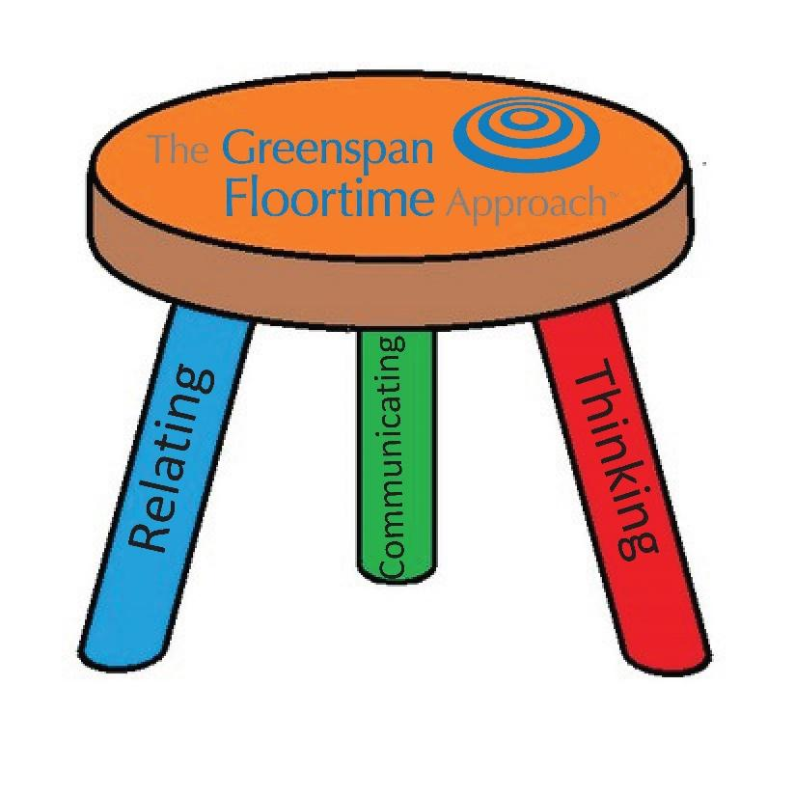
When Dr. Greenspan created Floortime in the '80s, now known as The Greenspan Floortime Approach®, he said that Floortime is an intervention that works on relating, communicating, and thinking. These three big-picture goals are the basis for everything one will do while partaking in a Floortime session.
While his six primary developmental milestones from his Greenspan/DIR™ Model are the actual goals we're addressing within these sessions, each of the milestones pertains to our ability to relate, communicate, and think.
At The Floortime Center, all of our therapists work on relating, communicating, and thinking within all therapeutic sessions. They are not trying to elicit specific adult-chosen outcomes or teach the child a particular skill. Instead, they help a child deepen and expand their ability to relate with various people around a variety of emotions. They encourage communication, both nonverbally and verbally, while helping children understand the adult's nonverbal gestures and verbal communication. They also create challenges that motivate a child to interact, adapt, create, problem-solve, and think. Integrating these three sets of goals makes these OT and SLP sessions Greenspan Floortime-based.
If you take away one of these sets of goals: relating, communicating, or thinking, we no longer are practicing Greenspan Floortime, but some other developmental approach that is unlikely to achieve the same comprehensive outcomes. We call this concept the Greenspan Floortime™ Three-Legged Stool.
If we take away one of the legs; relating, communicating, or thinking, the stool no longer stands on its own. Without all three legs, we are no longer 'supporting' a child's optimal holistic development when providing Greenspan Floortime™.
Of the stool's three legs, the most frequently overlooked leg is ‘Thinking’. Therapists and parents find it difficult to let a child problem solve and think for themselves because it's not quick or convenient. Our ability to think drives our ability to problem-solve, create, and adapt, which are all necessary social-emotional skills to be successful adults.
Most children who go through developmental interventions when they are young develop the ability to relate, connect with people, and improve their communication skills. Unfortunately, most children doing other versions of Floortime or other developmental and behavioral interventions do not develop the adaptability, problem-solving, creativity, and thinking skills necessary to succeed. As a result, they move through the early stages of life where thinking, creativity, and adaptability are targeted less in school and less necessary. Social dynamics become more complicated as they age, requiring greater adaptability and more complex social patterns. Academic concepts also increase in complexity, requiring abstraction and thinking outside the box.
Many of these children struggle and withdraw from the world when they no longer feel they can understand these explicit or implicit expectations. These challenges typically appear around third, fourth, or fifth grade and sometimes sooner. Children with special needs, ADD, ADHD, and other executive functioning challenges are particularly susceptible.
Our ability to create, problem-solve, adapt, and think are necessary elements of social-emotional health. Unfortunately, most professionals do not understand how to work on these things and instead focus on achieving specific adult-led outcomes and skills. To achieve the same results that Dr. Greenspan achieved with the ‘super star’ kids he helped live free of limitations who exceed every one of their doctors' diagnostic expectations, we have to make sure that we utilize all three legs of the Greenspan Floortime™ Stool.

